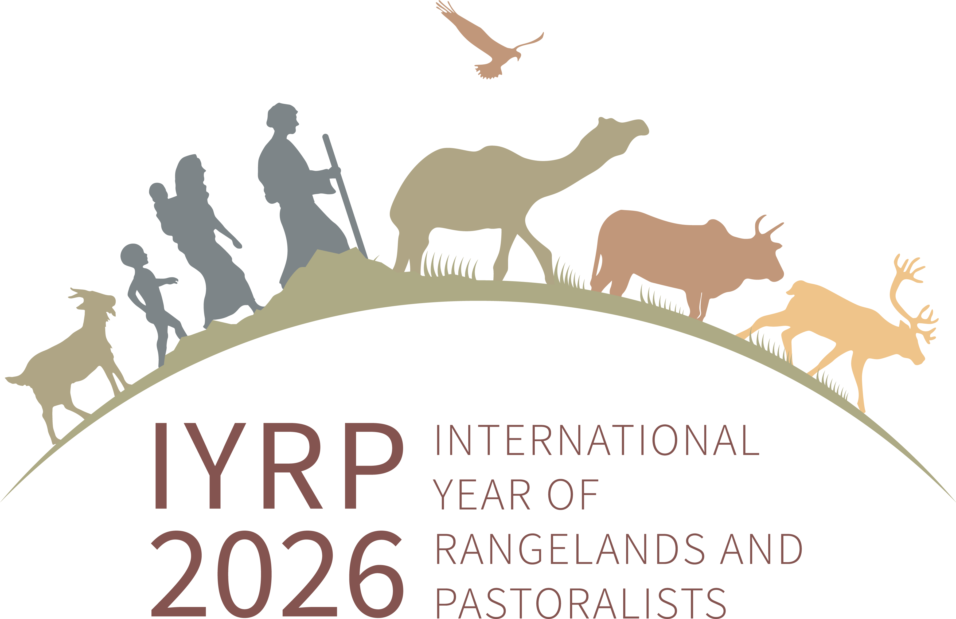
UPDATE FROM
Eastern and Southern Africa Regional IYRP Support Group (ESA-RISG)
August 2022
Report by Ken Otieno with contributions from Pius Loupa, Lauren Ongesa & Igshaan Samuels
Introduction
The Eastern and Southern Africa (ESA) Regional IYRP Support Group (RISG) was established in December 2020 at a kick-off meeting organised by Ann Waters-Bayer from the IYRP International Support Group (ISG). This fitted into several initiatives already underway to promote rangelands and pastoralism in ESA, to which different individuals contributed directly and/or through their institutions of affiliation. Their efforts included inputs during the Fourth Session of the United Nations Environment Assembly (UNEA4) in Nairobi in March 2019 as well as lobbying through the Rangelands Initiative – coordinated then by ILRI (International Livestock Research Institute) and RECONCILE (Resource Conflict Institute) – to encourage government ministries in the region to support the IYRP proposal made by the Government of Mongolia to the UN in 2019. The Coalition of European Lobbies for Eastern African Pastoralism (CELEP) also made substantial contributions through its members and affiliates in the IYRP ISG presenting at various FAO meetings.
Accomplishments
The ESA-RISG has held three meetings, which have created a greater momentum in advocacy on various issues related to rangelands and pastoralist. During the first meeting, the group agreed on co-chairs, one coming from Eastern Africa (Ken Otieno) and one from Southern Africa (Igshaan Samuels). The group customised the flyer on the IYRP campaign for the purpose of better communicating with pastoralist organisations in ESA. Two working groups have been established, namely the Policy Working Group (initially coordinated by Igshaan Samuels) and the Communications Working Group (coordinated by Loupa Pius), each with representation from several countries in Eastern and Southern Africa. Hannah Longole from Uganda volunteered to keep the ESA webpage on the IYRP website updated.
The initiatives in 2021 included continued lobbying and advocacy by the RISG members and through the Communications Working Group for member states – through their foreign affairs ministries and other relevant ministries – to support the Mongolian proposal to the UN to designate an IYRP. The Policy Working Group has been mapping and analysing policies and frameworks for sustainable rangelands and pastoralism in ESA and Africa more widely, and it is expected that this will lead to a targeted engagement strategy to advocate for pastoralism in the region. More members and organisations, including some in academia, have become involved in these efforts. Through in-country initiatives, RISG members have been engaging in related initiatives, for instance, the UN Food System Summit (UNFSS) Independent Dialogue in May 2021, which was organised by CELEP members Concern, RECONCILE and CRDD (Centre for Research & Development in Drylands), together with the Frontier Counties Development Council (FCDC).
Policy reviews
- Some ESA-RISG members contributed to the status review of the implementation of the African Union Policy Framework on Pastoralism and the Sendai Framework of Action on Disaster Risk Reduction and Climate Change. This largely sought to understand:
- Status of implementation (including the trend today due to ongoing policy reforms that have a bearing on sustainable rangelands and resources, the governance structures such as devolution and availing more resources to pastoral areas)
- Gaps and challenges in implementation
- Land governance issues
- Competing rights (public, private and community rights): e.g. refugee camps
- Documentation of best practices – from different sub-regions / Regional Economic Communities (RECs)
- Integrating Indigenous Knowledge and Practices (IKPs) into the adaptation strategies and pastoral resilience
- Emerging issues
- Way forward for sustainable pastoralism in Africa, including lessons learnt.
- Some ESA RISG members took part in assessing the status of implementation of the African Union (AU) International Bureau of Animal Resource (IBAR) Regional Strategy for Disaster Risk Reduction in ECCAS (Economic Community of Central African States), ECOWAS (Economic Community of West African States), IGAD (Intergovernmental Authority on Development), SADC (South African Development Community) and UMA (Arab Maghreb Union). This process has strategic bearing on the IYRP based on the level of the assessment.
- ESA RISG members, partners and friends of the IYRP distributed IYRP information at the Pastoralist Week of Karamoja in August 2022, a cultural event that brought together pastoralists from Ethiopia, Uganda, Kenya and South Sudan.
- Dialogues were held on cross-border and sustainable peace through the IGAD transhumance protocol.
- A national dialogue meeting on mining/ extractives and pastoralism was held in Karamoja.
- The AFSA (Alliance for Food Sovereignty in Africa) and ESAPN (Eastern & Southern African Pastoralists Network) regional dialogue on agroecology developed pathways for accelerating and championing pastoralism as a component of agroecology.
- LPP (League for Pastoral Peoples) held a webinar on 27 September 2022 on “Accounting for Pastoralists” which included a study in Mozambique, presented by Jacob Wanyama.
- The IYRP was popularised at the annual congress of the Grassland Society of Southern Africa in the Free State, South Africa, in July 2022.
- Members of the ESA RISG based in South Africa (SA) have been working on developing a framework for the rangeland management strategy in South Africa. Furthermore, the Range and Forage Policy spearheaded by the same IYRP members will be finalised in the first half of 2023.
- Members of the ESA RISG are guest editing a special issue comprising of 10 papers under the topic “African Pastoralism and Rangelands” in the African Journal of Range and Forage Sciences. The special issue will be released on 6 February 2023.
Other activities
- Kenya has formed the Rangeland and Grassland Association of Kenya (RGAC).
- ESA RISG members were involved in organising the second edition of the Perspectives on Pastoralism Film Festival and launching it in Prague.
- A side event on rangelands and pastoralism is being organised for the Annual General Meeting of RUFORUM Regional Universities Forum for Capacity Building in Agriculture) in December 2022. Igshaan Samuels, ESA RISG member and co-chair of the IYRP International Support Group, will deliver the keynote address on 14 December 2022 in Harare.
Resource mobilisation initiatives
The ESA RISG has drafted a proposal to mobilise resources for its work in the region. The outline is as follows:
Strategic objective: Improved rangeland management and tenure security in ESA

Main activities that need to be supported:
- Activity 1: Strengthening ESA-RISG platform to create awareness on the IYRP and deepen understanding of the importance of rangelands and pastoralism
- Activity 2: Strengthening network for biodiversity and ecosystem conservation for sustainable rangelands
- Activity 2: Establishing dialogue platforms to engage pastoralist groups and conservation organisations.
Contacts
ESA-RISG co-chairs:
- Andiswa Finca, Agricultural Research Council, South Africa (fincaa@arc.agric.za)
- Ken Otieno, RECONCILE, Kenya (kenotieno@reconcile-ea.org)
ESA webpage: https://www.iyrp.info/eastern-southern-africa

Co-Chair RISG-ESA and Director RECONCILE
Communications Working Group and African Wildlife Foundation (AWF)
Project Officer RECONCILE
Co-Chair IYRP International Support Group / Agricultural Research Council, South Africa

